**AWS Assignment**

**Create EC2 Instance:**

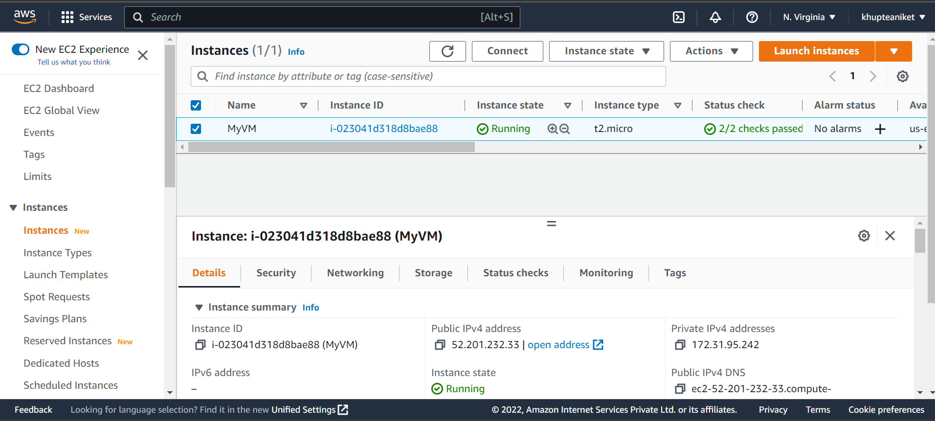

**Create RDS Instance:**

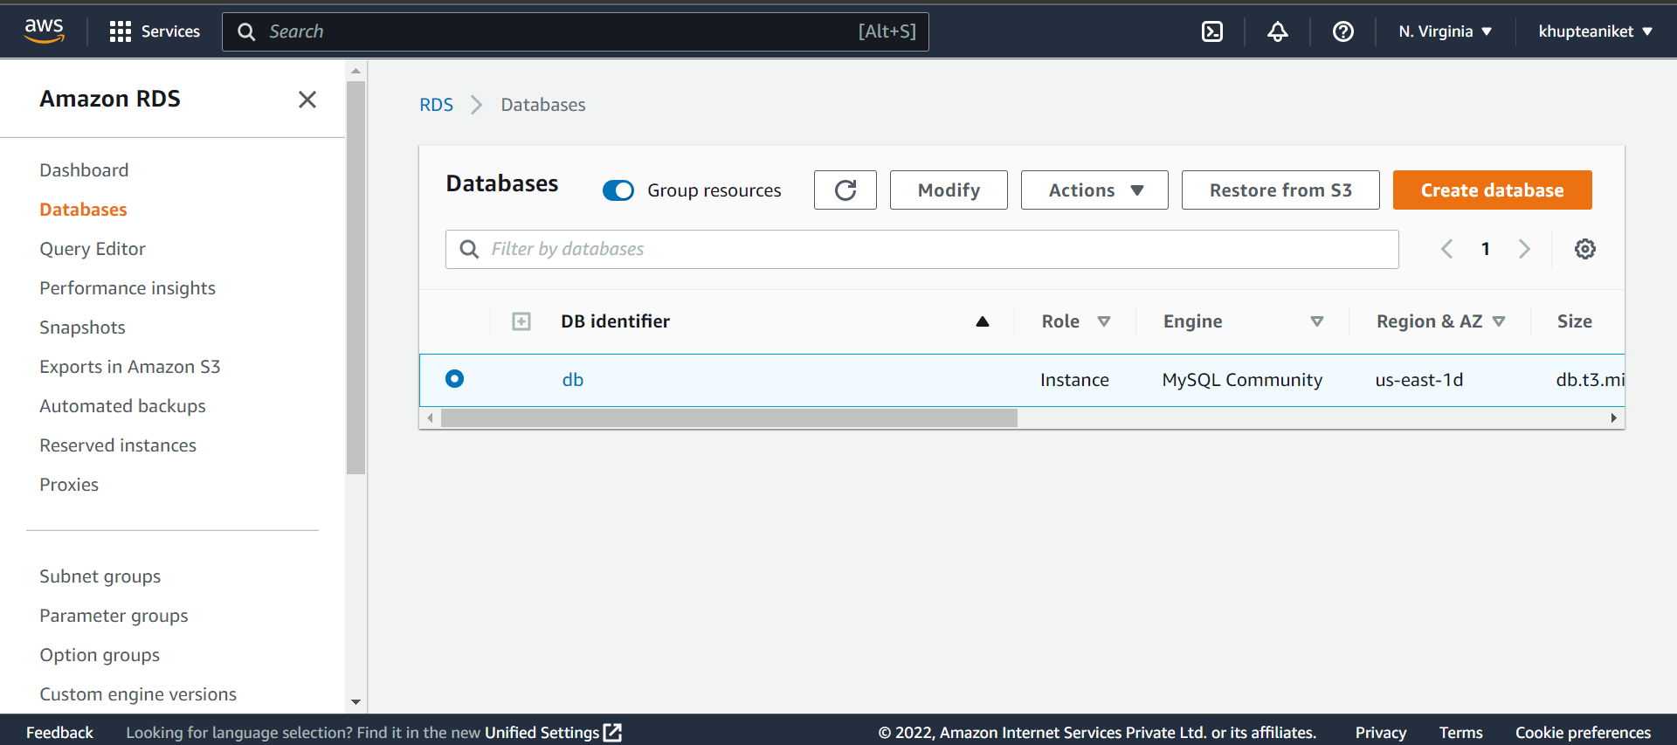

**Connect to MobeXTerm:**

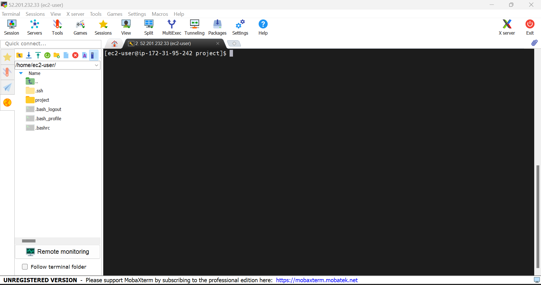

**Connecting RDS with Workbench:**

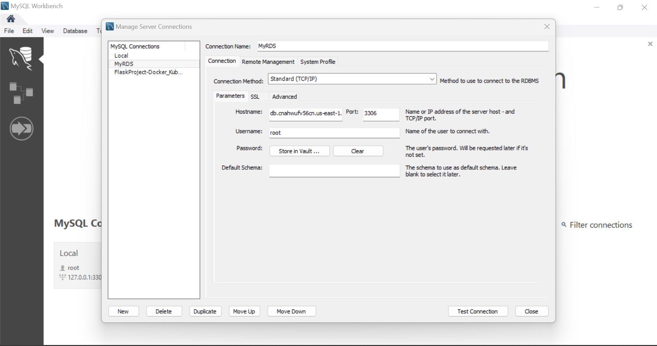

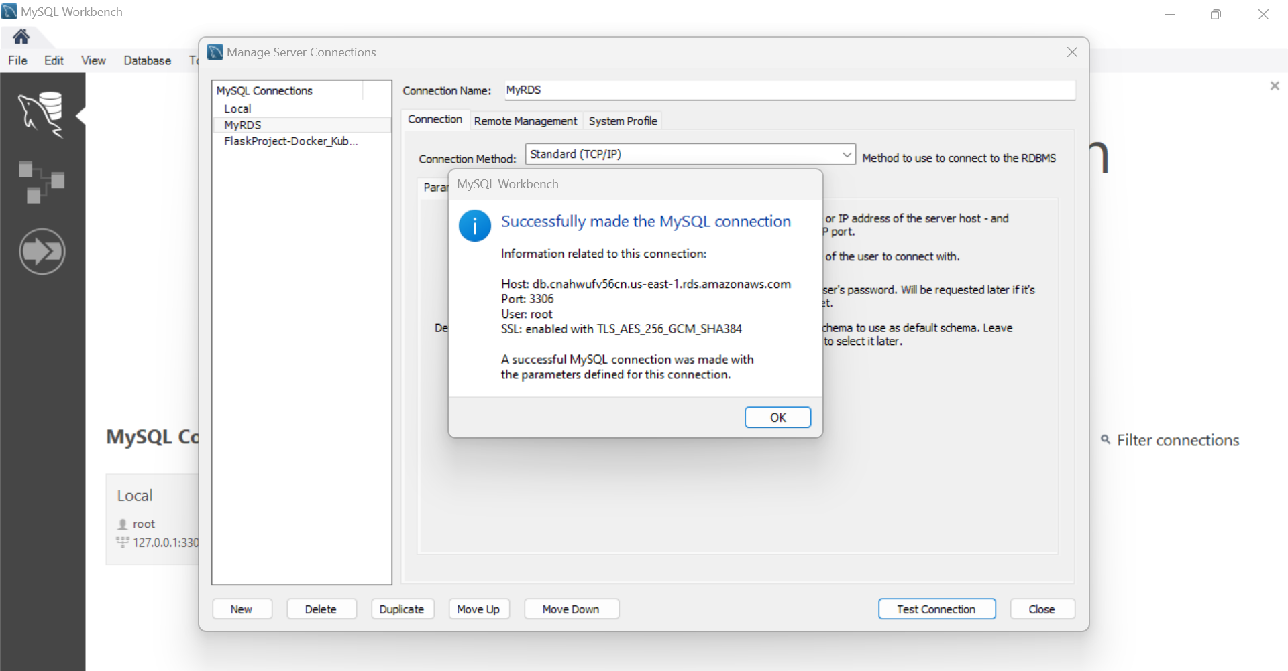

**Upload Project Files On AWS S3:**

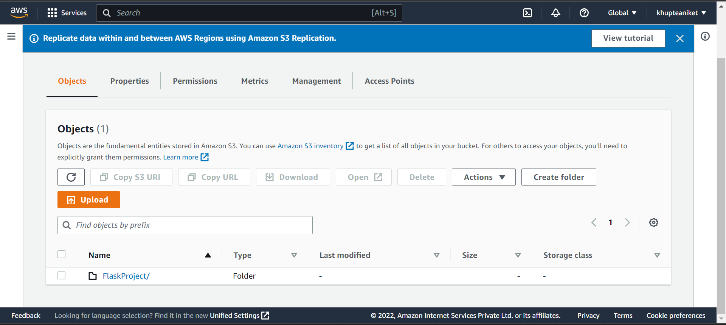

**Connecting RDS with current Docker File:**

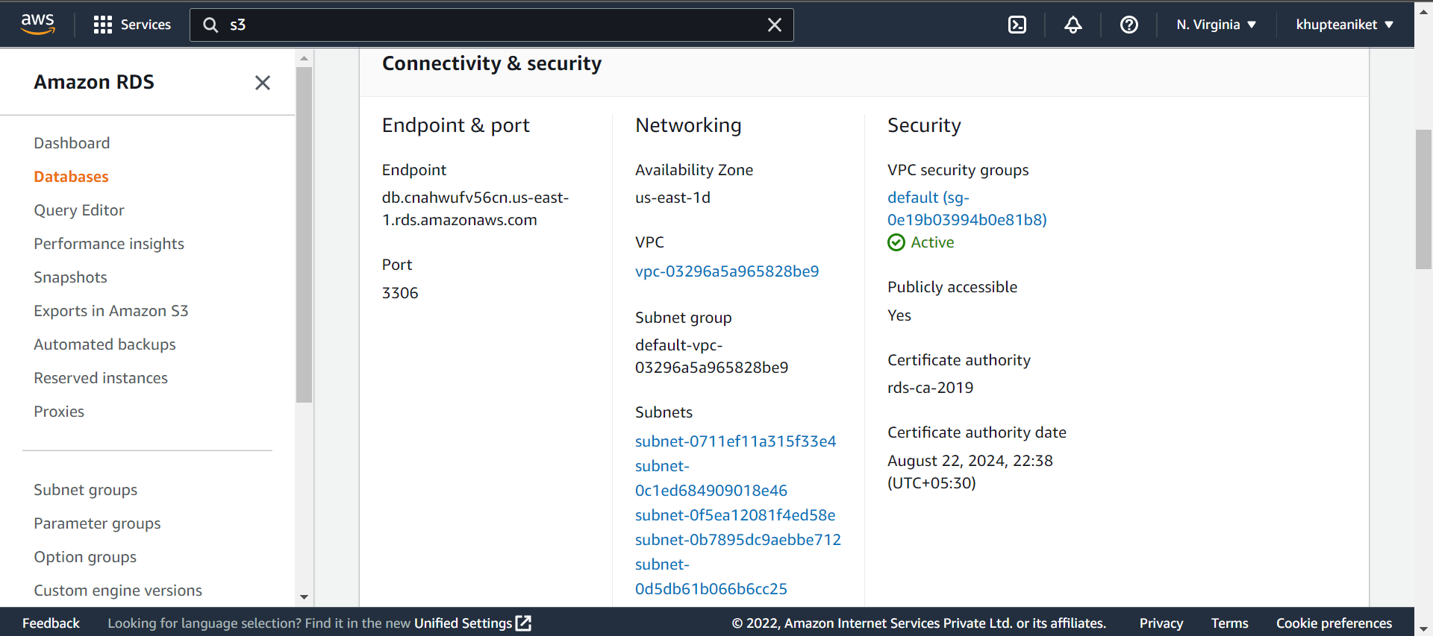

**Editing Docker-Compose file and Adding Endpoint into Host:**

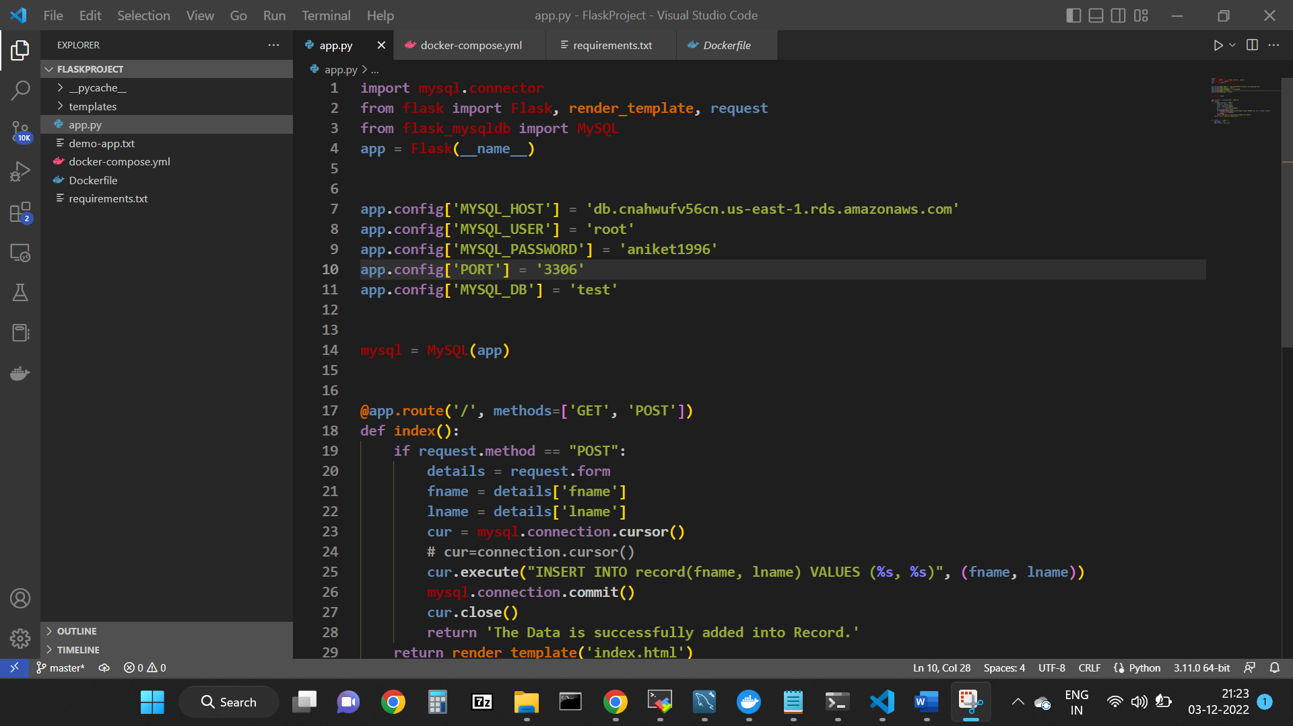

**Running Docker file Container:**

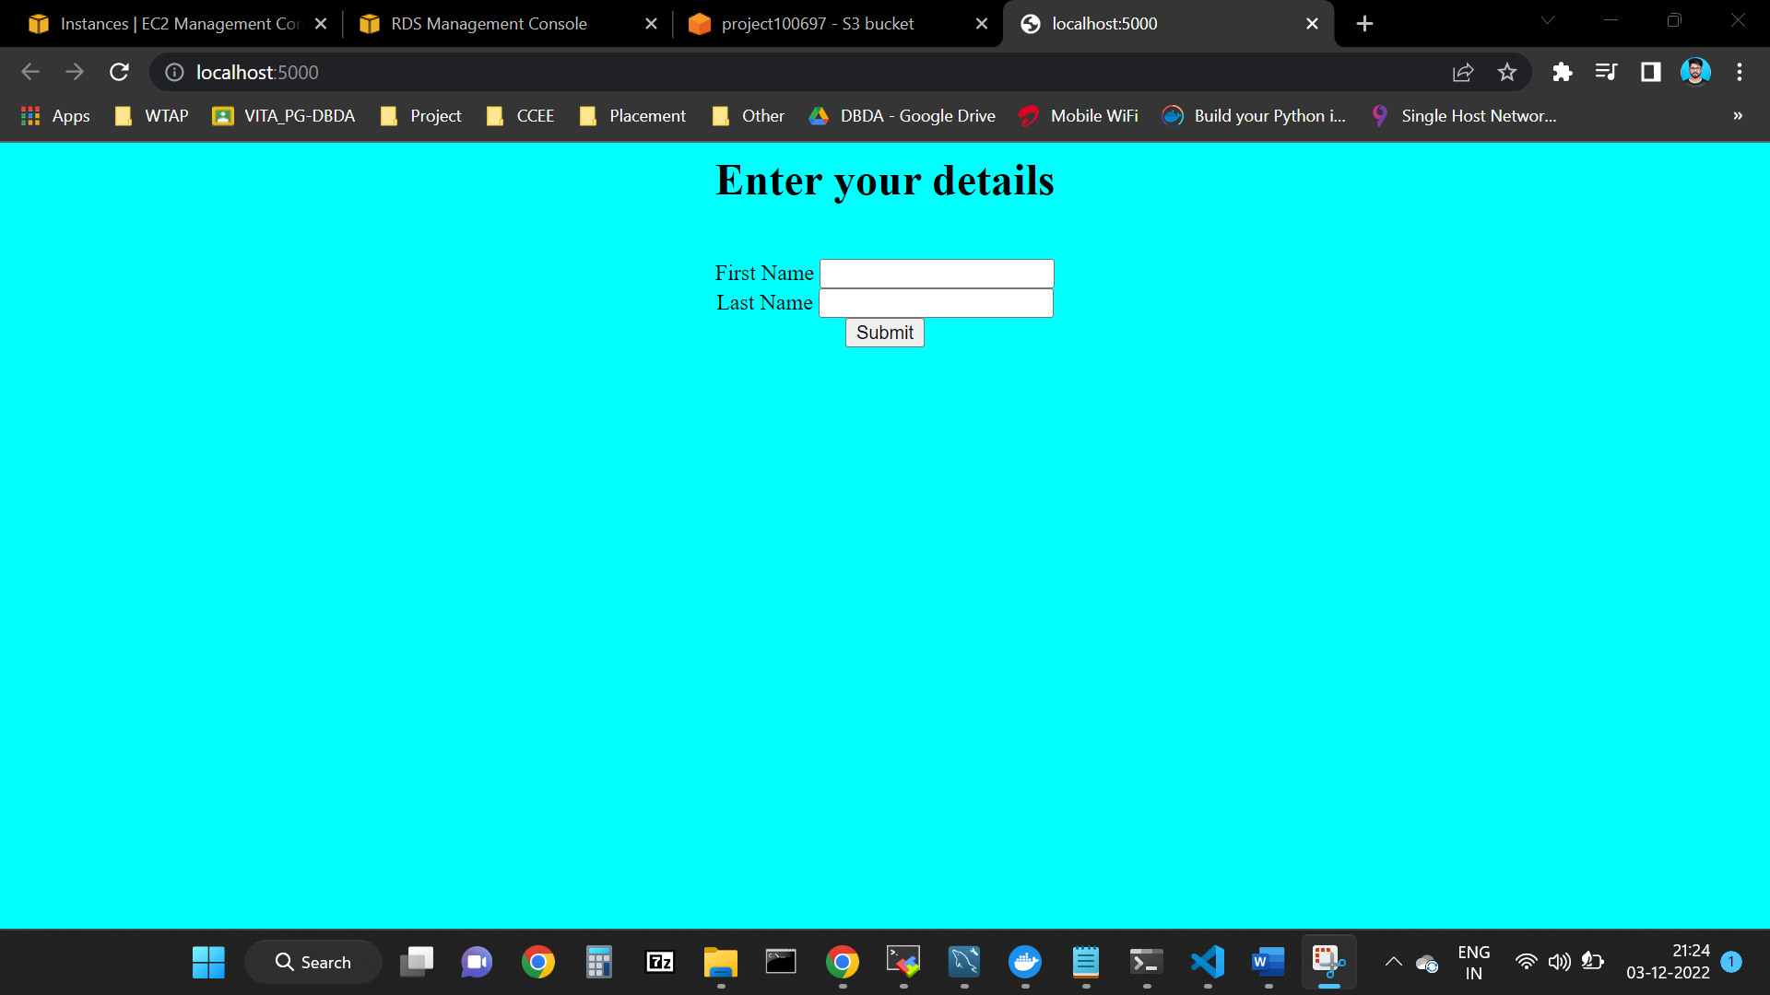

**Adding Record into UI:**

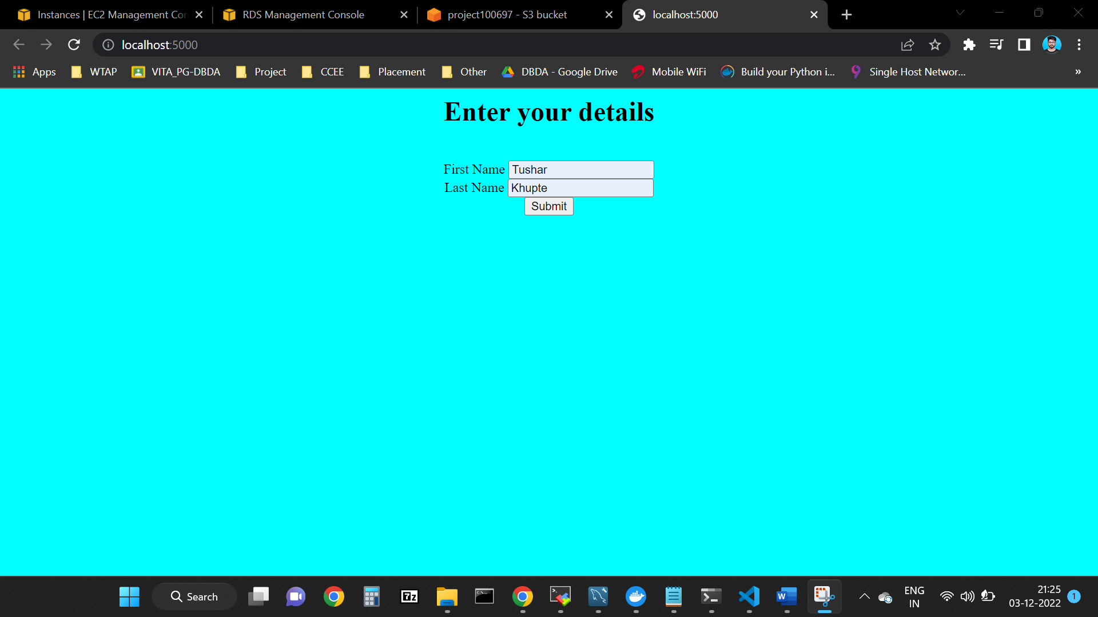

**Record added Successfully:**

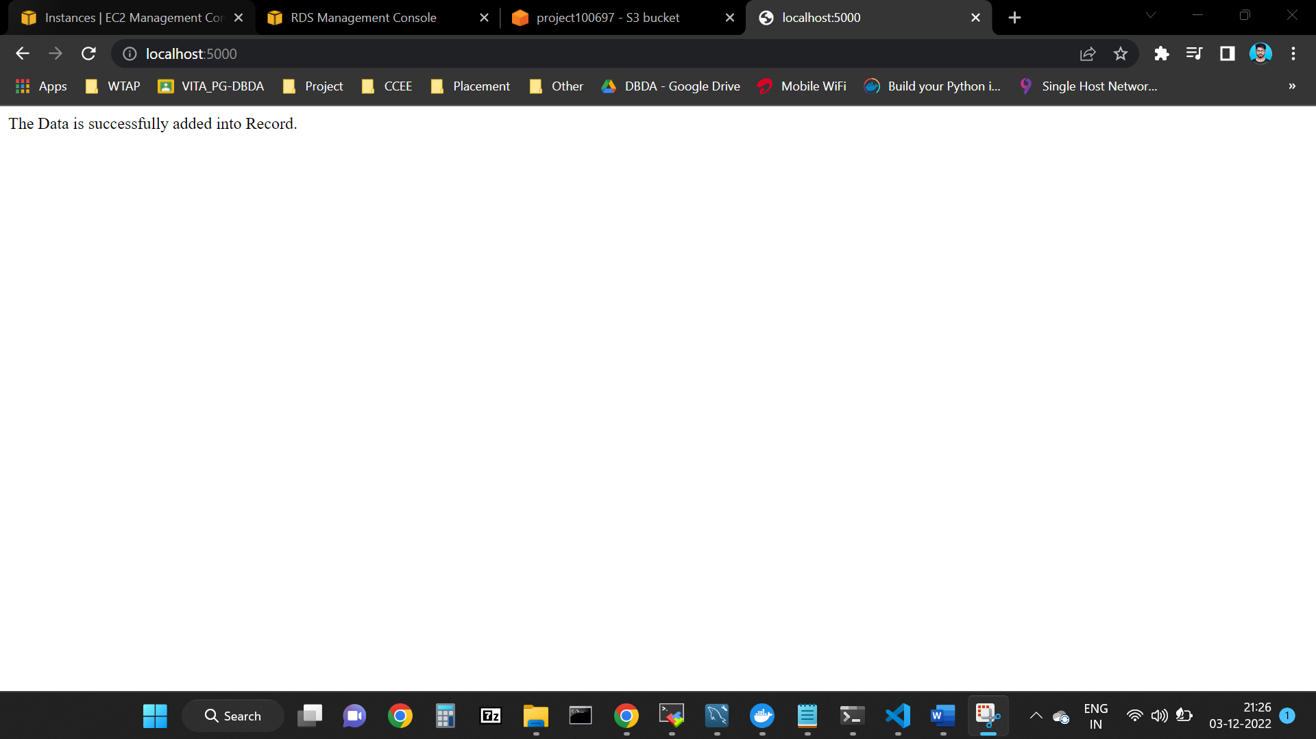

**Record can be seen in RDS Database:**

